
VICTORIA UNIVERSITY

OBJECT ORIENTED PROGRAMMING

GROUP G
KIDULA MARK
WADABA ALEX
APORU JOTHAM
DEBORAH
QUESTION ONE A
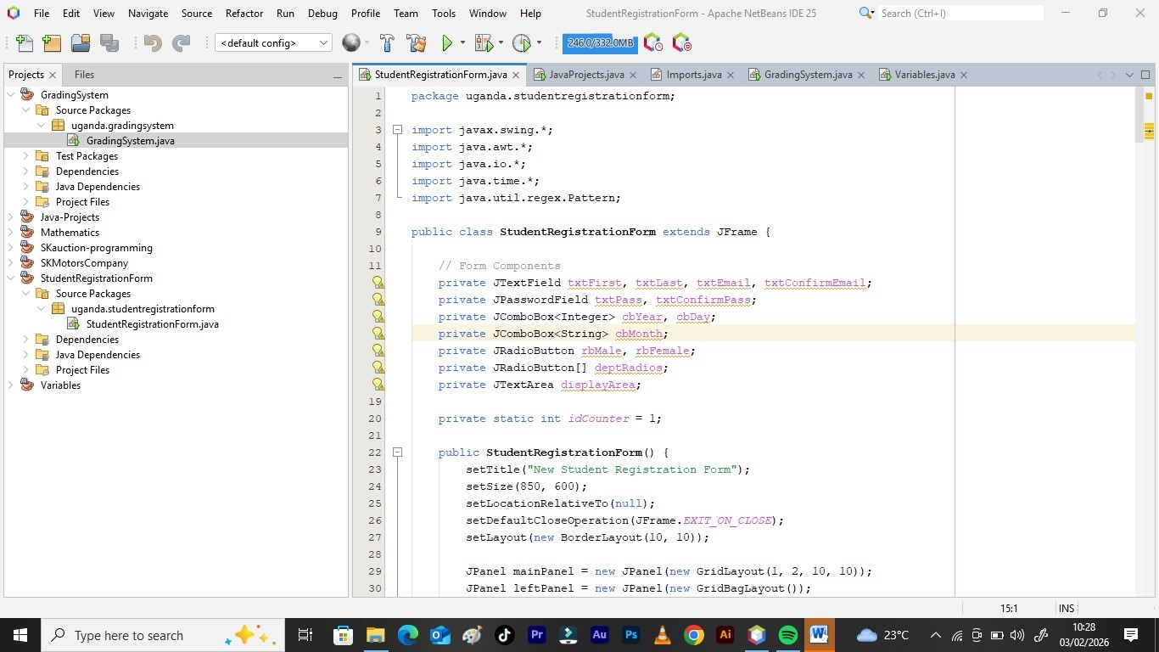
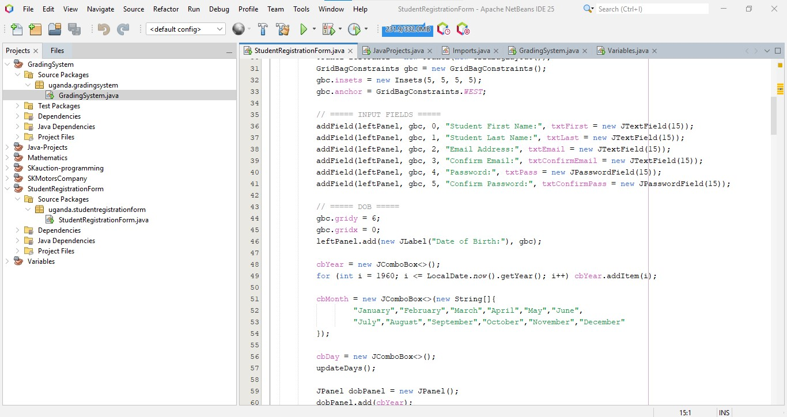
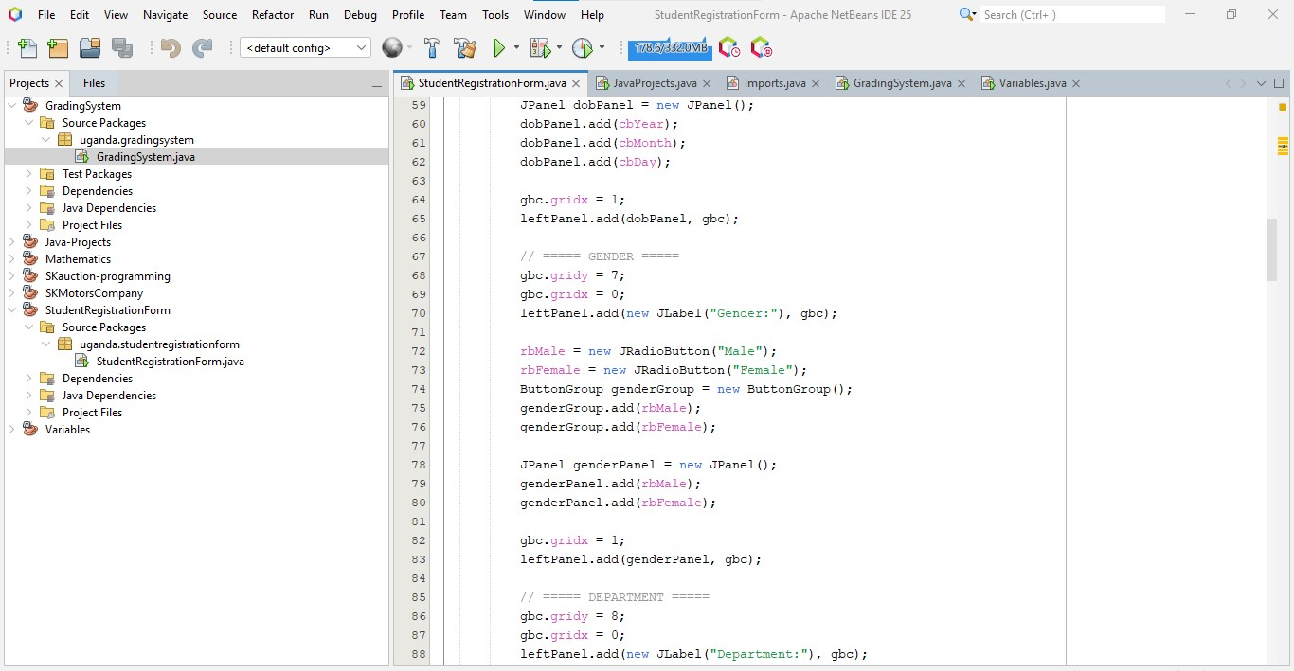
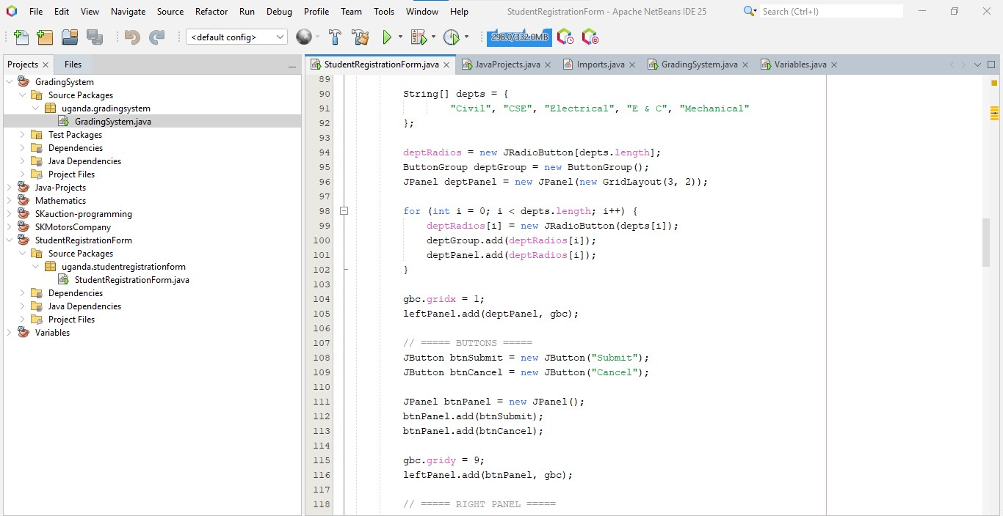

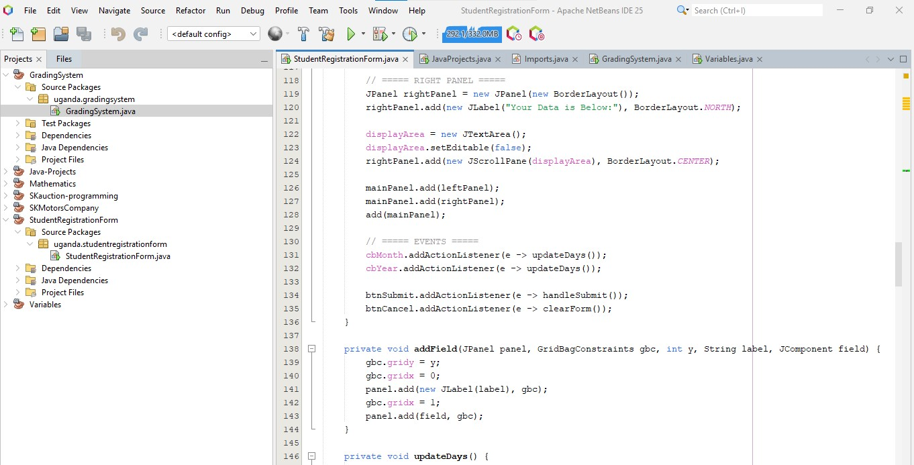

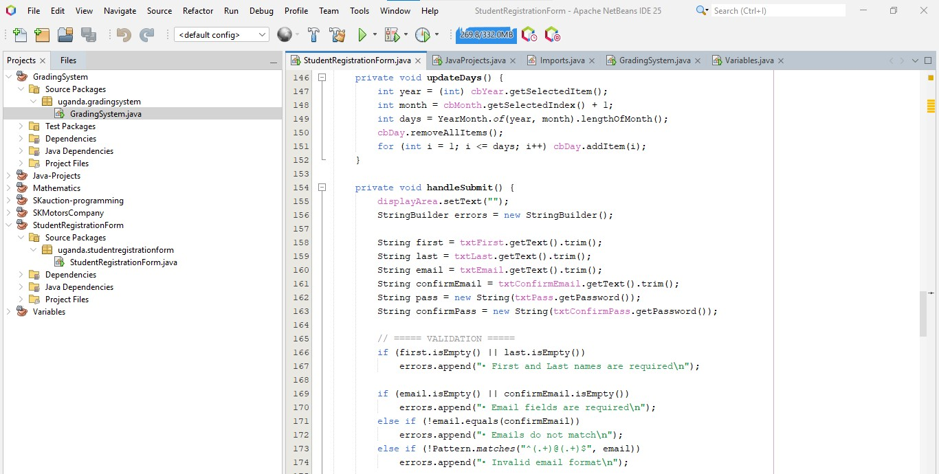

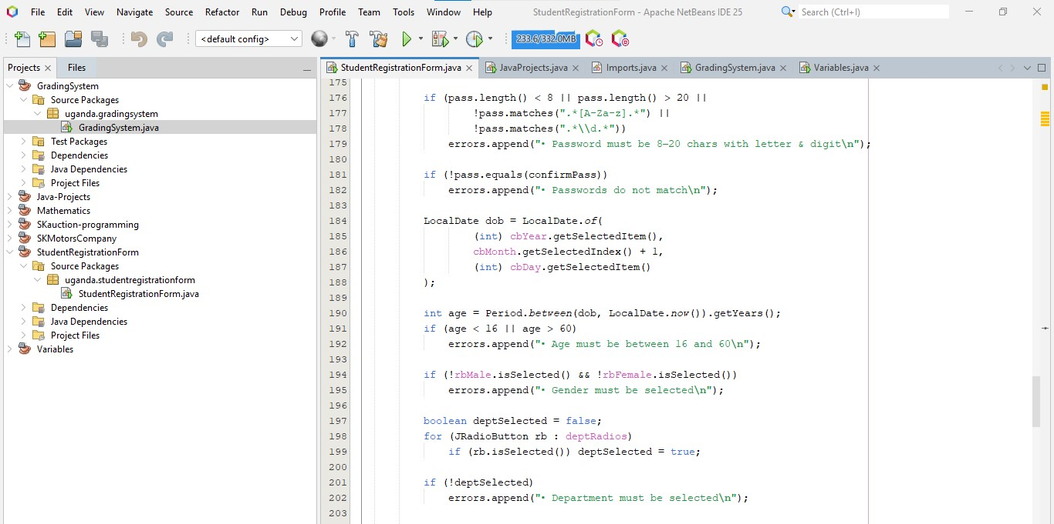

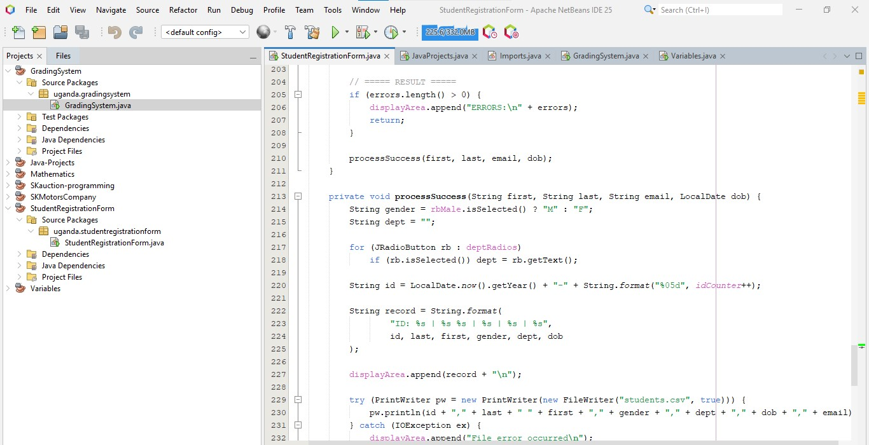

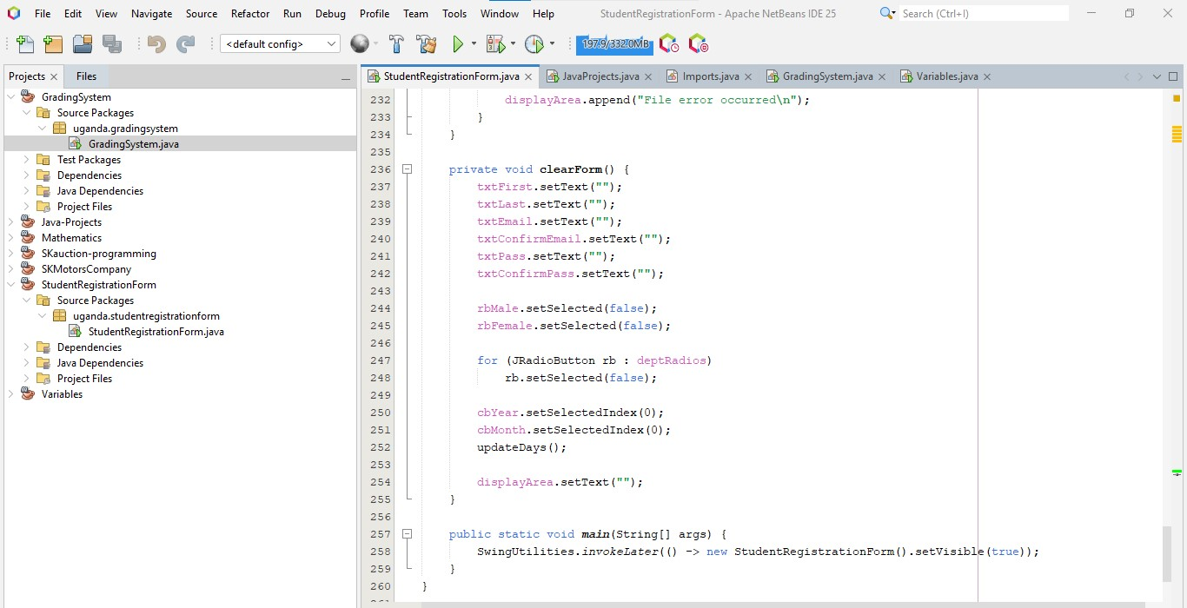
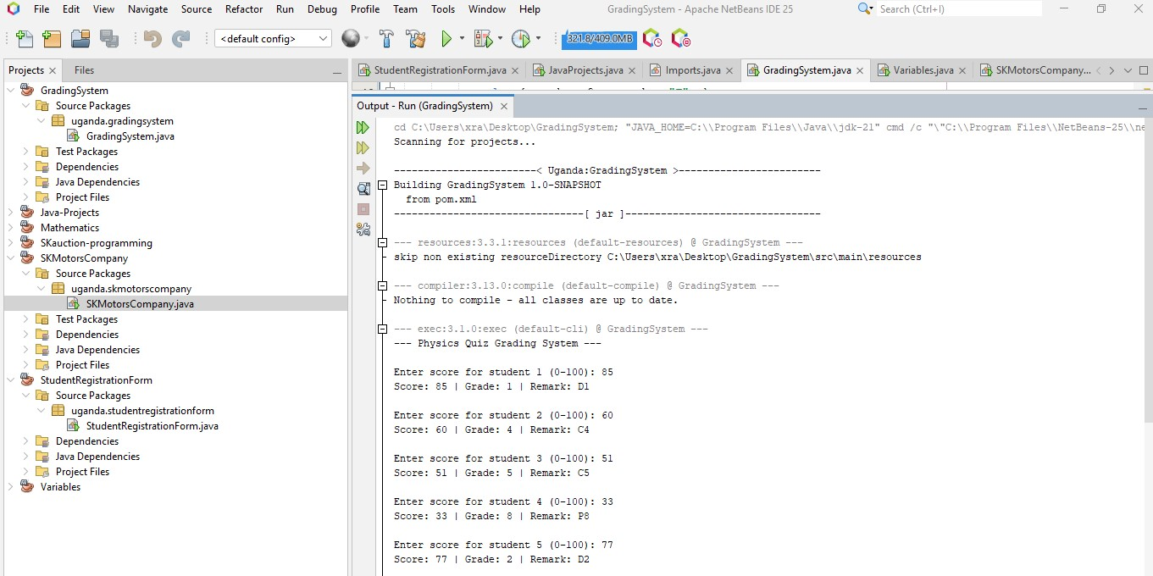
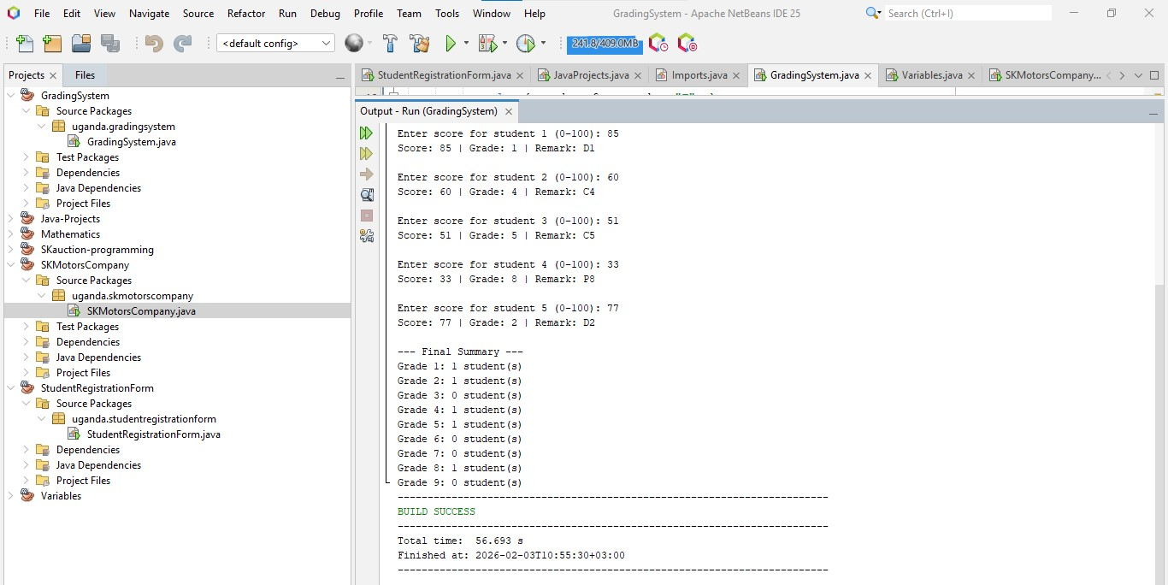
https://github.com/nannonosumayiya-coder/GRADING-APPLLICATION
PROJECT OVERVIEW
The program automates the process of evaluating student scores, assigning specific academic grades and remarks, and generating a statistical summary of performance.
The Grading System application processes results for a fixed batch of five students. It utilizes a controlled loop to capture inputs and uses a multi-tier conditional structure to categorize performance based on standard grading scales.

Key Features
- Iterative Processing: Uses a while loop to process exactly five student records sequentially.
- Input Validation: Ensures that all entered scores fall within the logical range of 0 to 100; invalid entries trigger an error message and a retry.
- Grading Logic: Implements a detailed if-else-if ladder to assign grades (1–9) and remarks (e.g., D1, C3, P7, F).
- Summary Statistics: Utilizes an array (grade Counts) to keep a running tally of how many students achieved each specific grade.

Grading Scale Reference
The system evaluates scores based on the following threshold table:
Score Range | Grade | Remark
80 - 100 | 1 | D1 (Distinction)
75 - 79 | 2 | D2 (Distinction)
66 - 74 | 3 | C3 (Credit)
60 - 65 | 4 | C4 (Credit)
50 - 59 | 5 | C5 (Credit)
45 - 49 | 6 | C6 (Credit)
35 - 44 | 7 | P7 (Pass)
30 - 34 | 8 | P8 (Pass)
0 - 29 | 9 | F (Fail)
QUESTION ONE B

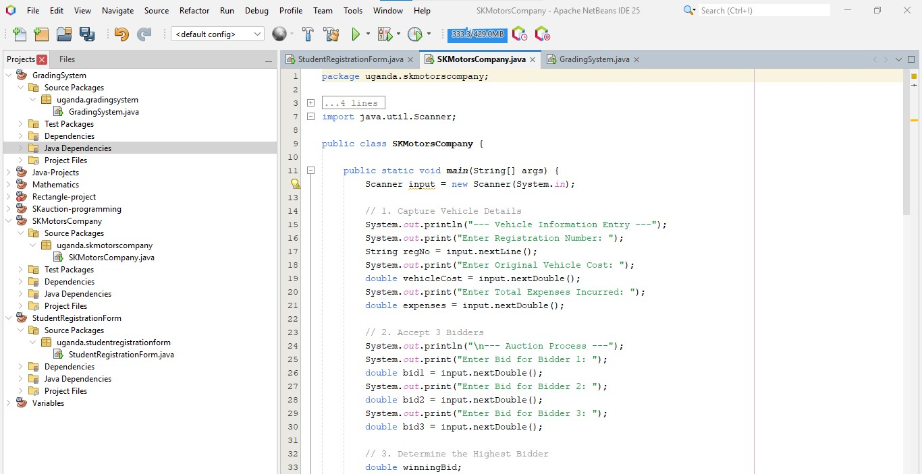

QUESTION TWO
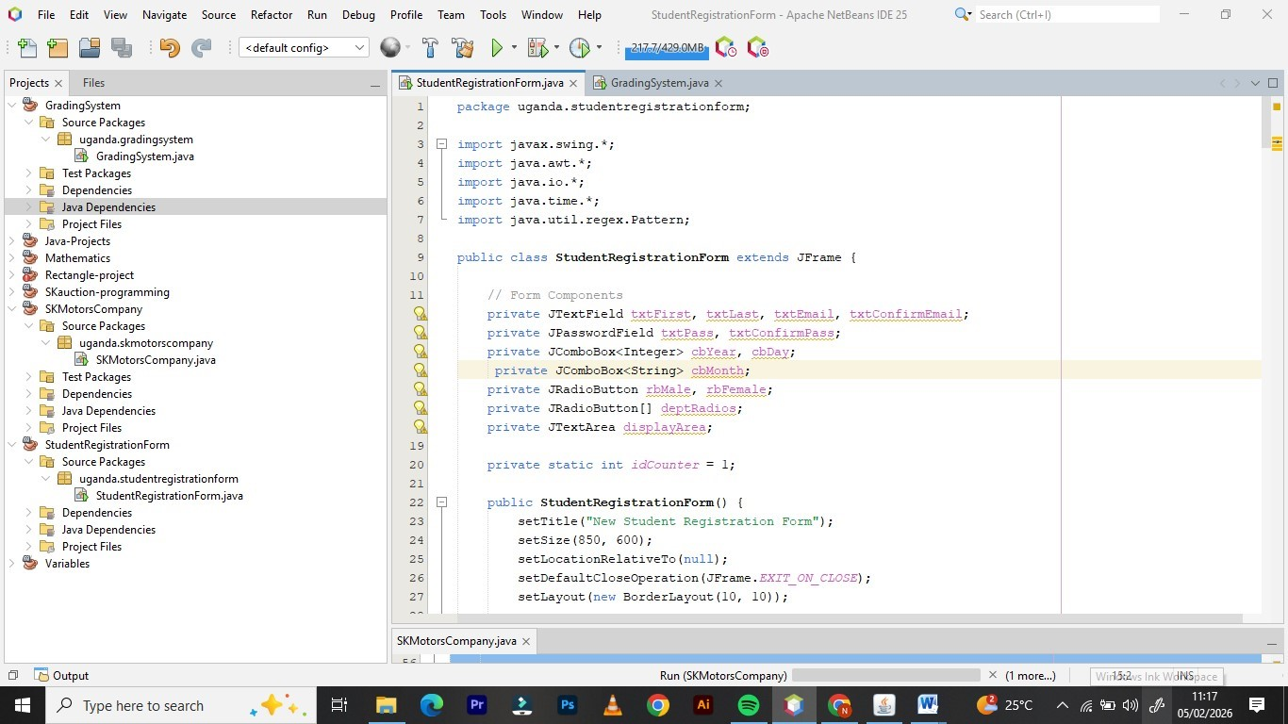
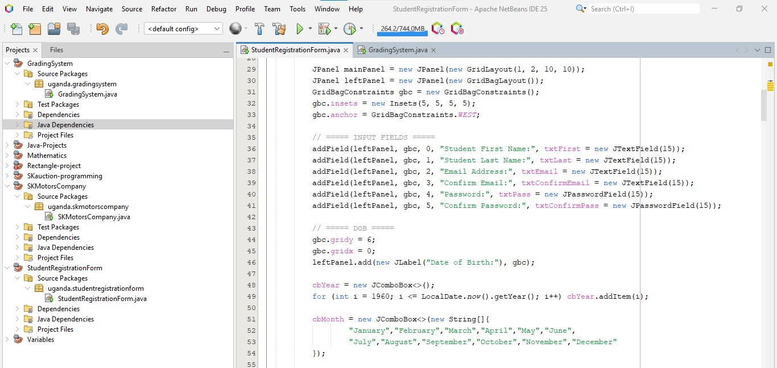

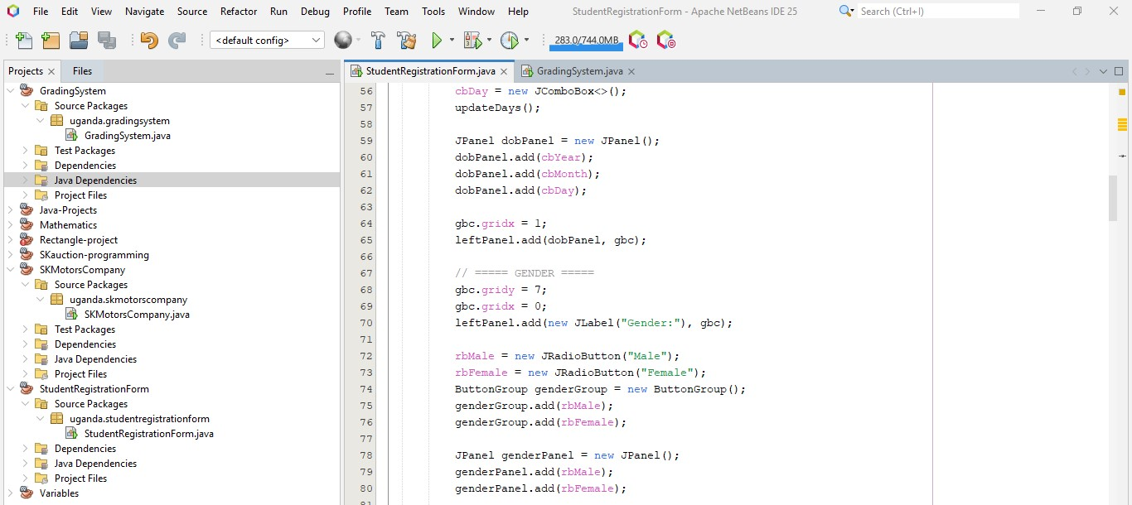

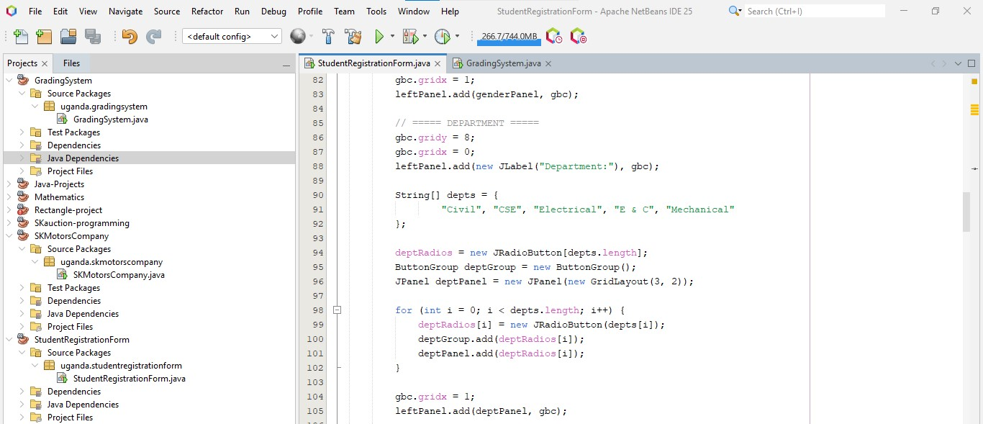

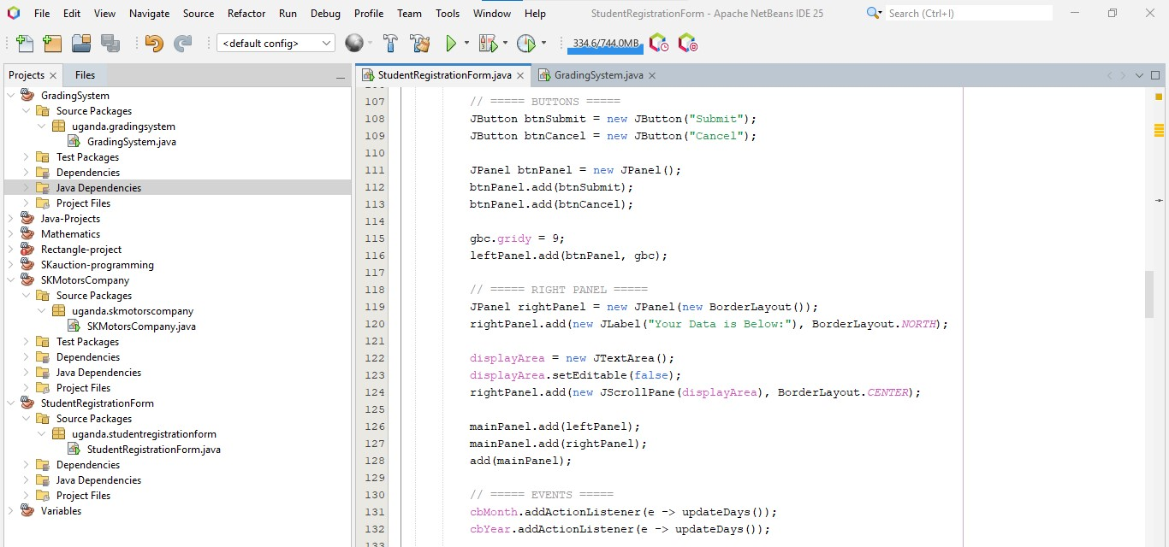

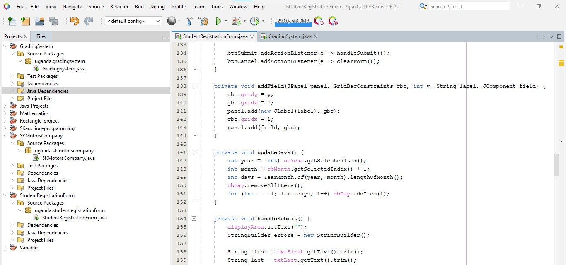

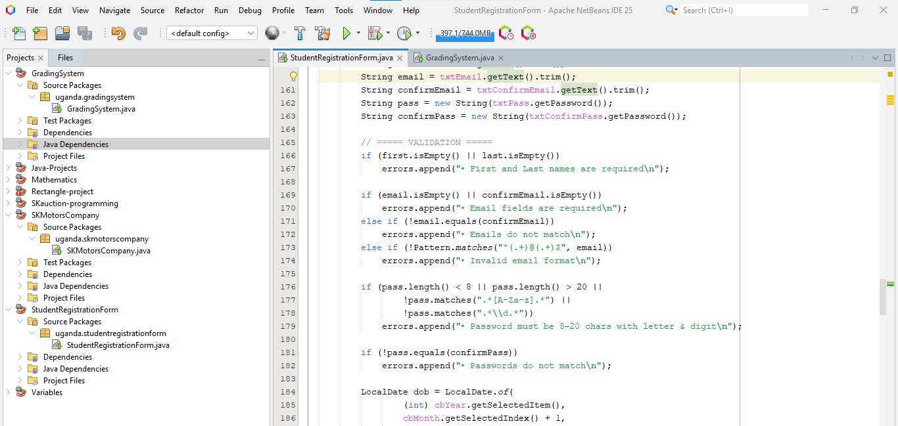
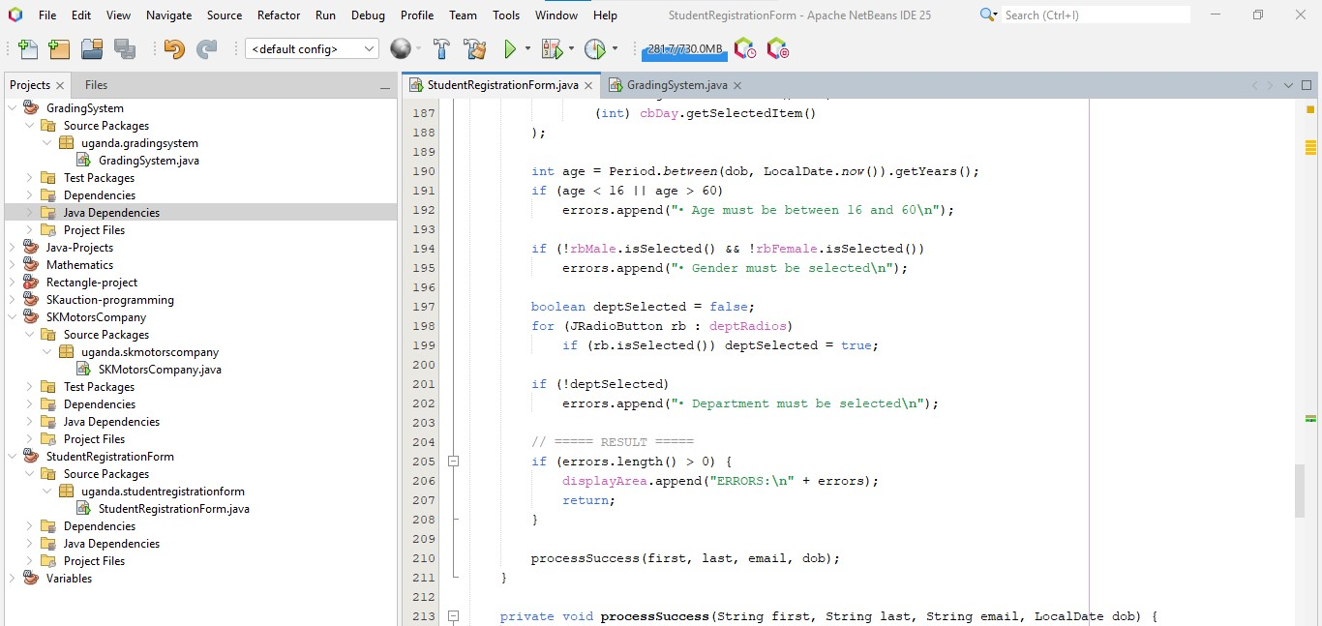

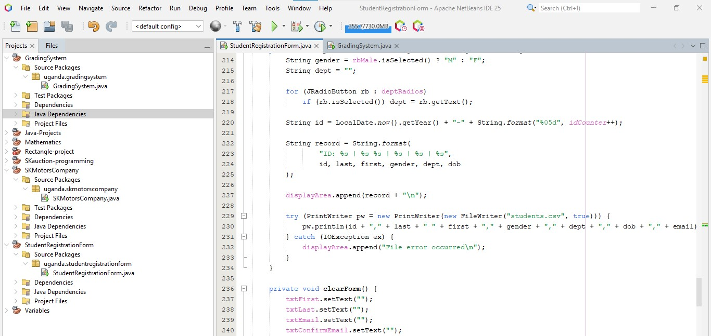
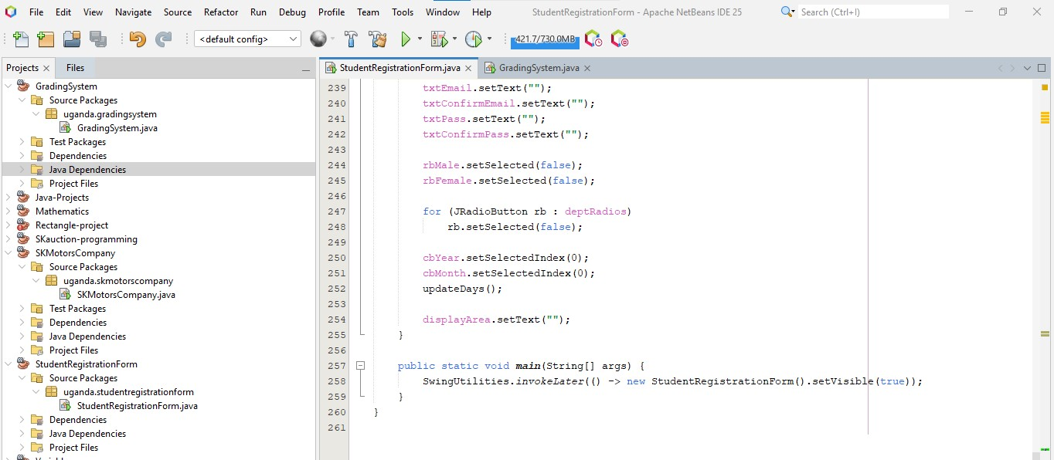

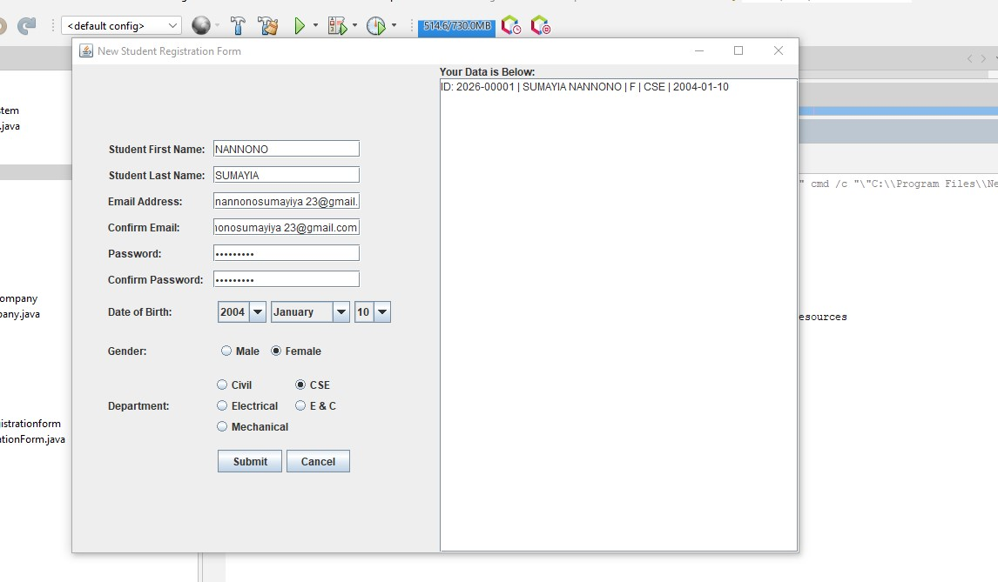

PROJECT OVERVIEW
The Student Registration Form is a comprehensive data entry tool designed for academic institutions. It features a split-pane interface where the left side is dedicated to a structured input form and the right side acts as a live data preview area. The system is built to ensure data integrity by enforcing strict validation rules before any record is finalized.

Key Features
- Comprehensive Data Capture: Collects personal information including name, email, date of birth, gender, and academic department.
- Dynamic Date Selection: Automatically calculates the correct number of days in a month based on the selected year and month (including leap year support).
- Robust Input Validation:
  - Email Verification: Checks for correct email formatting and ensures confirmation fields match.
  - Password Security: Enforces a length of 8–20 characters and requires a mix of letters and digits.
  - Age Eligibility: Restricts registration to individuals between the ages of 16 and 60.
- Automated ID Generation: Generates a unique student ID based on the current year and a sequential counter (e.g., 2026-00001).
- Persistent Storage: Successfully submitted records are appended to a local students.csv file for external spreadsheet analysis.

Technical Specifications
- GUI Library: javax.swing and java.awt.
- Layout Management: Uses GridBagLayout for precise alignment of form fields and BorderLayout for the overall frame structure.
- Data Validation: Utilizes Regular Expressions (Regex) for email and password pattern matching.
- File I/O: Implements PrintWriter and FileWriter to handle comma-separated values (CSV) logging.

How to Run
- Environment Setup: Ensure you have the Java Development Kit (JDK) installed.
- Compilation: javac StudentRegistrationForm.java
- Execution: java uganda.studentregistrationform.StudentRegistrationForm
- Submission: Fill out the required fields. If successful, the data will appear in the right-hand preview box and be saved to students.csv. If errors exist, they will be highlighted in the preview area.

